Importing an EXCEL file into MATLAB

We are going to use the Import Wizard to import the file gasprices.xls into MATLAB. First go toD2L, locate gasprices.csv and save it to your desktop or flashdrive. gasprices.csvcontains historical data on weekly premium gasoline prices excluding taxes, in U.S. dollars per gallon, from seven countries over recent years.

To use the Import Wizard, choose File → Import Data from the menus at the top of the MATLAB desktop. A dialog box opens that allows you to browse for files on your computer. Browse for gasprices.csv.
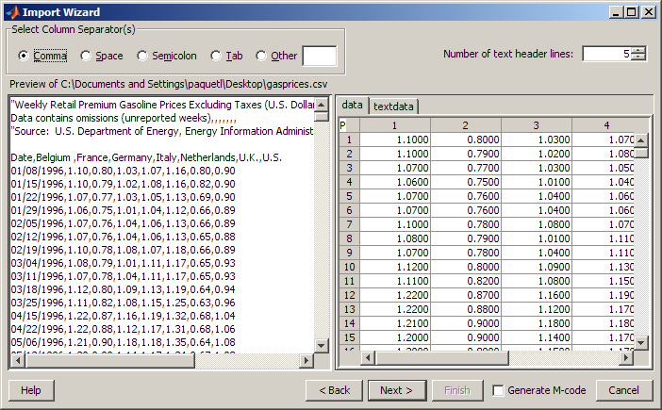

Choose Matrix ➔ import.
Click Next, then Finish. Click on the Workspace tab in MATLAB. Variables are stored in the workspace.

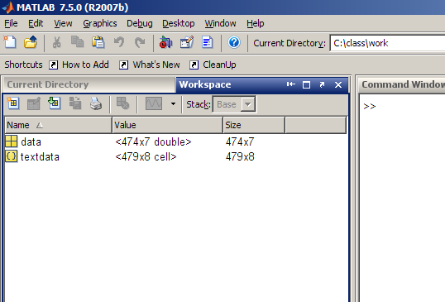

To open an array in the array editor, double-click the name of the array in the workspace. You can also right-click and open the array.
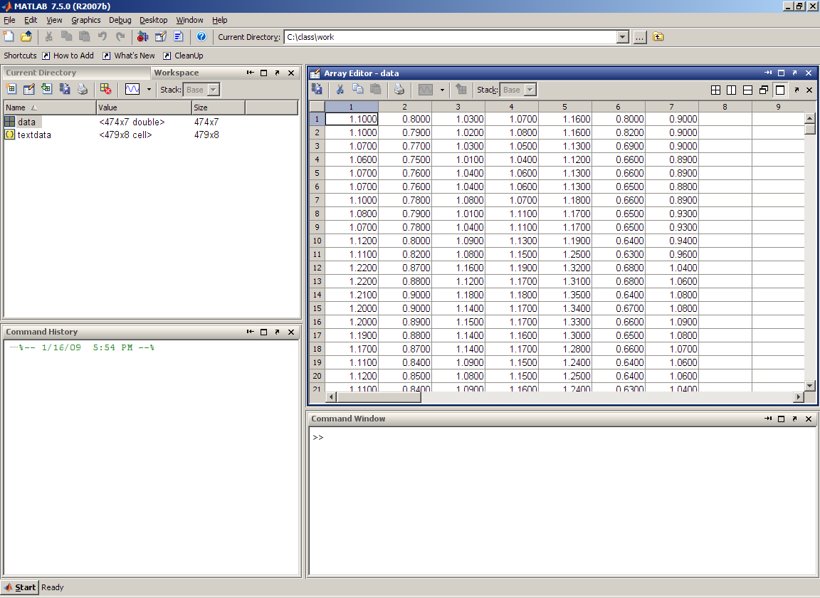
You can use the Array Editor to create new variables in the base workspace. Select the first column and right-click. Choose Create Variable From Selection. A variable called ‘unnamed’ is created in the base workspace. It can be renamed by right-clicking it in the Workspace Browser and choosing Rename.
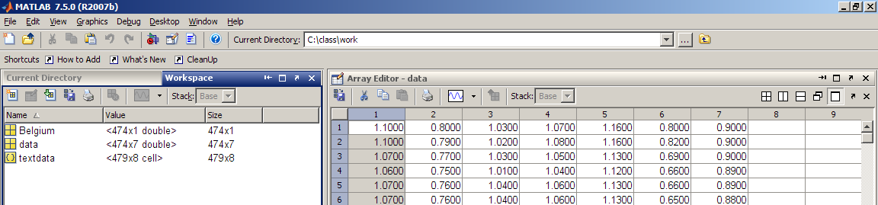

Now we will create a plot. Select Belgium. The plot button can now be selected. Clicking on the dropbox arrow gives plot type options. You can also use the plot button in the Array Editor.
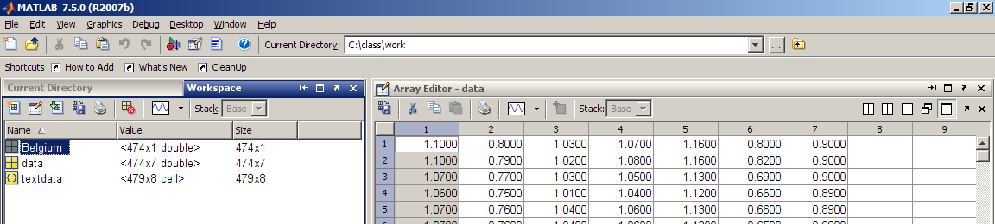

A figure pops up.
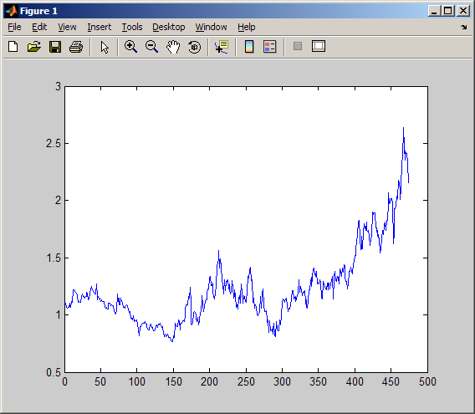

The Show Plot Tools button will open up various tools to help format the plot. You can also click on View and open the Figure palette and Property Editor.
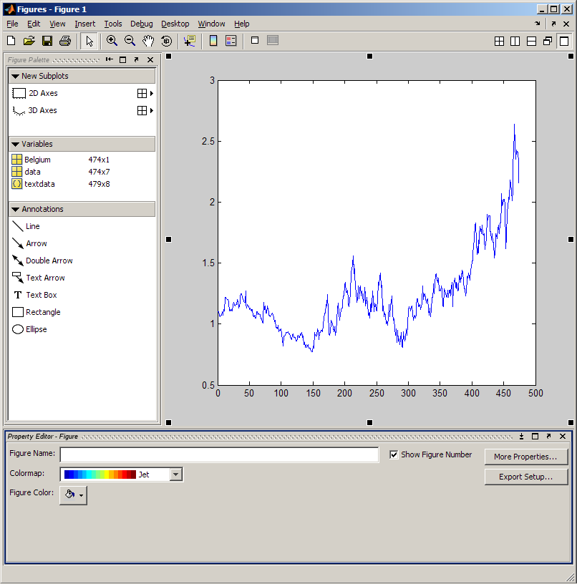

At this point you will click on various parts of the plot and explore the various editing options. If you created more variables you can drag them from the variable window to the figure window to plot it.

